Mark these spelling tests and write down how many each animal scored out of 10!

Walter the Wallaby | Keith the Kangaroo | Kevin the Koala | Wendy the Wombat
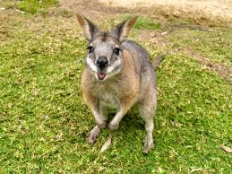 | 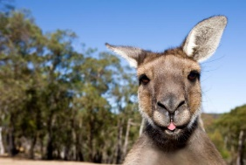 |  | 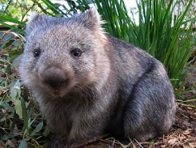
considerable | considerible | comsidreable | considerrable
applycable | aplicable | applicable | applicible
tollerable | tolerable | tolerible | tollerible
opperable | opurable | operible | operable
dependable | deppendable | dependible | deppendible
comfurtable | comfortable | comfirtable | comfortible
reazonable | reesonable | reasonable | reasonible
perishible | perishuble | perrishable | perishable
breakible | brakeable | brakeable | breakable
fashunable | fationable | fashionable | fashionible
How many correct? | How many correct? | How many correct? | How many correct?
(write number in this box) | (write number in this box) | (write number in this box) | (write number in this box)

Write out the sentences below, in your homework book, using the correct spelling of the words above:

- The rule is not ___________ to the adults.
- The pain was not _________.
- Less than half of the trains were ________.
- Go careful – that vase is easily _________.
- I put a ____________ amount of effort into my work.
- Thank you for being my most __________ employee.
- The child always wanted the most ___________ clothing.
- They made a __________ amount of money.
- The chair was very ___________.
- The foodbank were collecting non-__________ foods.

Answers:

Walter the Wallaby | Keith the Kangaroo | Kevin the Koala | Wendy the Wombat
considerable | considerible | comsidreable | considerrable
applycable | aplicable | applicable | applicible
tollerable | tolerable | tolerible | tollerible
opperable | opurable | operible | operable
dependable | deppendable | dependible | deppendible
comfurtable | comfortable | comfirtable | comfortible
reazonable | reesonable | reasonable | reasonible
perishible | perishuble | perrishable | perishable
breakible | brakeable | brakeable | breakable
fashunable | fationable | fashionable | fashionible

- Applicable
- Tolerable
- Operable
- Breakable
- Considerable
- Dependable
- Fashionable
- Reasonable
- Comfortable
- Perishable

